MILESTONE 4 REPORT

Dashboard Development & Final Integration
Objective
To develop a real-time dashboard for monitoring, analytics, and complete system integration.

Work Done

1. Dashboard Development
- Built using Streamlit
- Created UI for:
  - Video feed
  - Alerts
  - Analytics

2. Live Video Integration
- Displayed real-time detection
- Showed bounding boxes on dashboard

3. Violation Visualization
- Displayed:
  - 🔴 UNSAFE status
  - 🟢 SAFE status
- Listed violations clearly

4. Analytics
Displayed:
- Total frames
- Total violations
- Safe detections
- Detection ratio

5. Logging System
- Stored violations in CSV:
timestamp, violation
- Implemented:
  - Event-based logging
  - No duplicate entries

6. System Integration
Integrated:
- YOLO model
- Detection pipeline
- Alert system
- Dashboard UI

7. Testing & Evaluation
- Tested:
  - Accuracy
  - Latency
  - Stability

8. Final Output
- Working dashboard system
- Demo-ready application

Deliverables
- Dashboard with analytics
- Logging system
- Final project report

Outcome
A complete AI-powered workplace safety monitoring system with real-time detection, alerts, logging, and analytics.
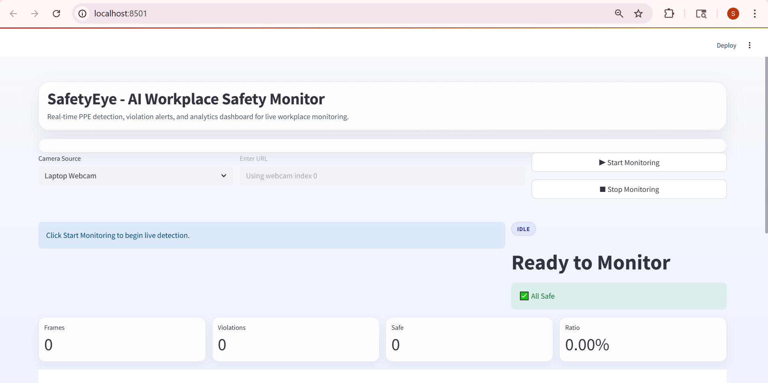
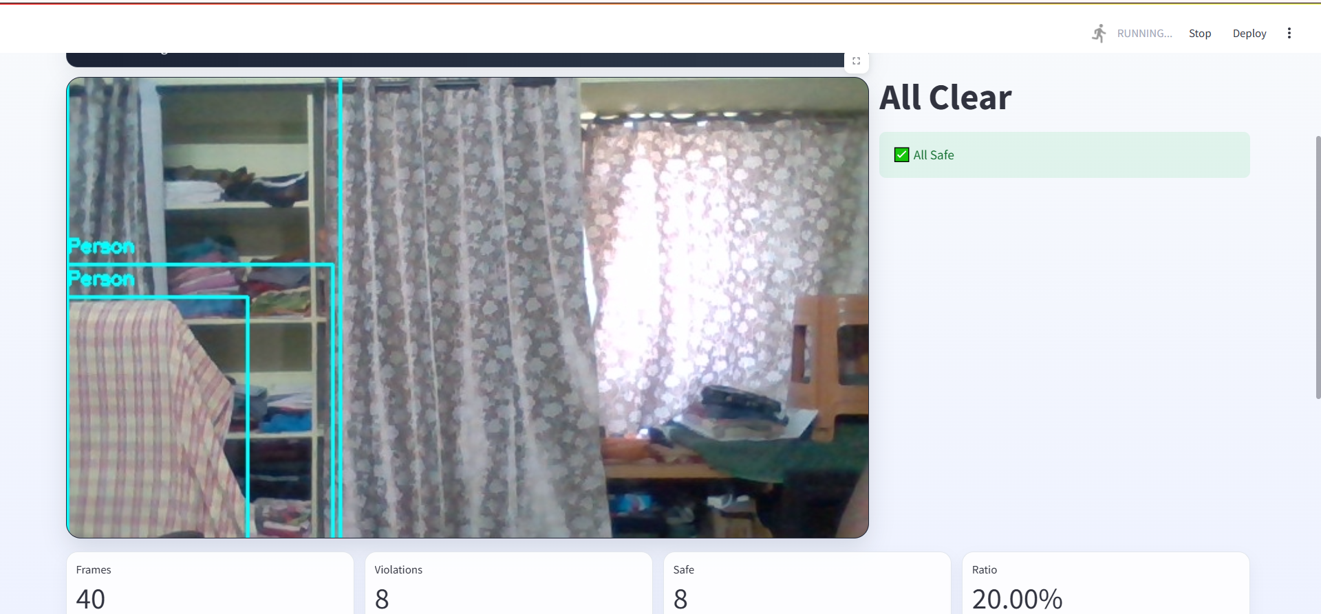
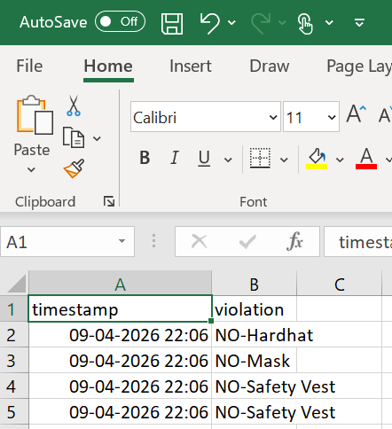

FINAL SUMMARY
The SafetyEye system represents a comprehensive integration of computer vision and deep learning technologies to enhance workplace safety monitoring in real time. By leveraging the power of advanced object detection models such as YOLOv8, the system is capable of accurately identifying Personal Protective Equipment (PPE) including helmets, safety vests, and masks from live video feeds.
The system continuously processes video input from webcams or CCTV sources and performs real-time analysis to determine whether workers are complying with safety regulations. It intelligently detects violations such as the absence of helmets or safety vests and immediately flags these conditions. This ensures that unsafe situations are identified without delay, enabling prompt corrective action.
In addition to detection, the system includes a robust alert mechanism that visually highlights violations on the video feed and displays warnings on the dashboard. This helps supervisors quickly understand and respond to safety issues. Furthermore, a logging system is implemented to record each violation along with timestamps, creating a structured record that can be used for audits, reporting, and long-term analysis.
The interactive dashboard interface, developed using Streamlit, provides a centralized platform for monitoring all activities. It displays live video streams, real-time alerts, and analytical insights such as violation counts, safety compliance rates, and trends. These analytics help organizations evaluate safety performance and make data-driven decisions to improve workplace conditions.
Overall, the SafetyEye system is not only functional but also scalable and adaptable to different industrial environments. Its ability to combine detection, alerting, logging, and visualization into a single integrated platform makes it a practical solution for modern workplace safety management. This project demonstrates how AI can be effectively utilized to reduce risks, improve compliance, and promote a safer working environment.

